Bilkent University

Department of Computer Engineering

CS319 – Object Oriented Software Engineering Project

Project short-name: Donkey Kong Game

Design Report (Final Draft)

Group 3E

Fuad Ahmadov

Çağatay Küpeli

Sine Mete

Arkın Yılmaz

Supervisor: Bora Güngören

Analysis Report (Final Draft)

Dec 1, 2017

This report is submitted to the Department of Computer Engineering of Bilkent University in partial fulfillment of the requirements of the Senior Design Project course CS319/3.

Contents

1. Introduction 1

1.1 Purpose of the System 1

1.2 Design Goals 1

1.3 Definition, Acronyms & Abbreviations 2

2. Software Architecture 2

3. System Model 2

Design Report (Final Draft)

Project short-name: Donkey Kong Game

# Introduction

In this

## Purpose of the System

Donkey Kong Game is a re-mastered version of popular arcade game, Donkey Kong 1981. In this game, user try to reach finishing point without hitting any hostile obstacles. It is one of the well-designed game in its time, so it is user-friendly and easy to understand. Even though Donkey Kong 1981 was a successful game, it was lacking some features. In order to add them, the design and gameplay of the game is altered.

In addition, the original levels in Donkey Kong 1981 will not be remade for this system, instead levels will be redesigned. This allow us to show the new features of the game and make it much easier. This design choice allow us to make levels that shows what are the features added into the game.

## Design Goals

**Usability:** The design of Donkey Kong 1981 inspired us in terms of usability requirement. A person who never played Donkey Kong 1981, can play this game without any hesitation because every arcade game use the similar or same patterns for user inputs. We created a list of characteristics the user controls share in software.

* Control inputs should make sense. For example you cannot use UP button one keyboard to go right or left.
* Control inputs should be close to each other in order to create better gameplay experience.
* Control inputs should be easy to understand.
* There should be always a help option to explain core concepts of the game such as control inputs.

**Performance:** Performance is important design goal for games. You cannot expect people to enjoy the game if it has some optimization problems such as sudden FPS drops and freezes. In other words, the game should run at high FPS and should preserve it.

**Portability:** Portability is crucial for any software. In order to make Donkey Kong Game portable, Donkey Kong Game will be developed with Java because Java is one of the few programming languages which allows cross-platform portability. This attribute of Java allows Donkey Kong Game to work any environment which installed JRE; therefore user will not worry about operating system requirements.

**Reliability:** Reliability is another important design goal for games. The game system should be bug-free and it should not crash due to unexpected reasons. Reliability of system will be tested through the development of the system in order to not have any bugs and crashes at execution time.

**Extendibility:** Extendibility is a must for our system because as it was explained 1.1 our purpose for this system is to improve Donkey Kong 1981. Thus, the system should be coded in a way that it should be simple to add new components and features to the system.

* New levels should can be added just by creating a txt file with appropriate name.
* New power-ups and enchantments should can be added without changing old part of the code.

Trade-Offs

**Reusability vs. Performance:** Reusability is important for designs that might see some future usage in other projects. However we have no plan of making another arcade game. Therefore we are not planning to make our code usable unless we might decide to use the functionality inside another class.

**Memory vs. Speed:** Even though memory usage is important in order to make the game fast as possible, we are not concern about memory space.

Every objects which can be seen on the game panel will be created separately in order to make collision detection faster. This design choice will cost us so much memory; however, it will help us to detect collisions faster.

## Definition, Acronyms & Abbreviations

**Frame Per Second (FPS):** A measurement for how many unique consecutive images occur each second.

**Arcade Game:** A type of game genre that is a fast-paced action game, requiring hand-eye coordination skill to play.

**Cross-Platform:** Software that can run on multiple types of Operating Systems.

**Java Runtime Environment (JRE):** A set of software tools for development of Java applications.

# Software Architecture

# System Model

## Detailed Class Diagram

The full class diagram is attached to the next page in order to provide a better look on interactions between classes and subsystems.

Figure 3.1: Detailed Class Diagram

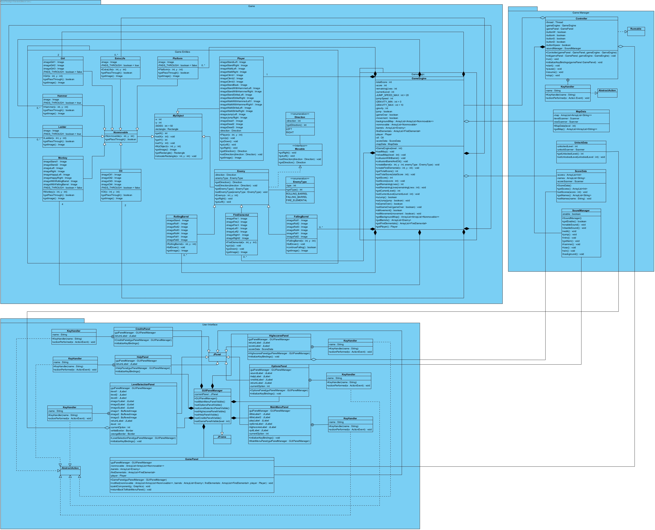

## Subsystems

### User Interface Subsystem

The User Interface Subsystem class diagram is attached to the next page in order to provide a better look on interactions between classes.

Figure 3.2.1: User Interface Subsystem

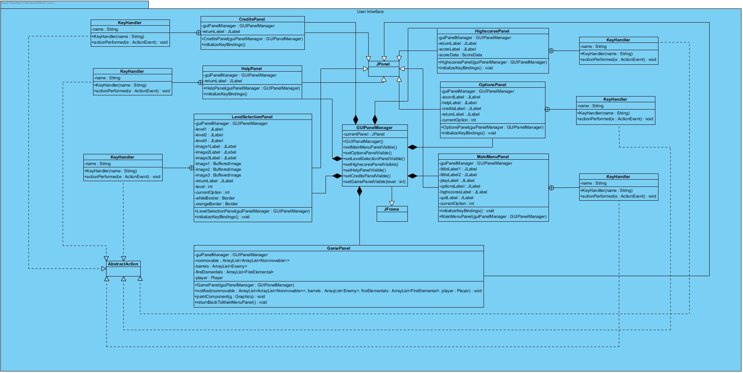

* + - 1. **GUIPanelManager** **Class**

GUIPanelManager class creates the main frame of the game and it is also handles which panel will be shown to user. Other classes in User Interface Subsystem cannot interact directly, instead they call GUIPanelManager class to make other class visible to user.

* GUIPanelManager extends JFrame

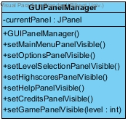

Figure 3.2.1.1: GUIPanelManager Class

**Attributes**

|  |  |  |  |
| --- | --- | --- | --- |
| private | currentPanel | JPanel | Keeps the current panel that is shown to the user |

**Constructors**

|  |  |  |
| --- | --- | --- |
| public | GUIPanelManager() | Creates GUIPanelManager object |

**Methods**

|  |  |  |  |
| --- | --- | --- | --- |
| public | setMainMenuPanelVisible() | void | Changes the current panel to MainMenuPanel |
| public | setOptionsPanelVisible() | void | Changes the current panel to OptionsPanel |
| public | setLevelSelectionPanelVisible() | void | Changes the current panel to LevelSelectionPanel |
| public | setHighscoresPanelVisible() | void | Changes the current panel to HighscoresPanel |
| public | setHelpPanelVisible() | void | Changes the current panel to HelpPanel |
| public | setCreditsPanelVisible() | void | Changes the current panel to CreditsPanel |
| public | setGamePanelVisible(level : int) | void | Changes the current panel to GamePanel with respected level name |

* + - 1. **KeyHandler Class**

KeyHandler class is a nested class that create an interaction between keyboard inputs from user and classes. Except for KeyHandler nested class inside Controller class which interact with GamePanel class and GameEngine class, every other class create its nested class with the same name. The rasoning behind this was it was easy to manage during implementation and easy to modify.

* KeyHandler implements AbstractAction

Figure 3.2.1.2: KeyHandler Class

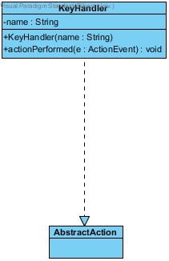

**Attributes**

|  |  |  |  |
| --- | --- | --- | --- |
| private | name | String | Keeps the name of the input from keyboard |

**Constructors**

|  |  |  |
| --- | --- | --- |
| public | KeyHandler(name : String) | Creates a KeyHandler object that convert user inputs from user into a meaning |

**Methods**

|  |  |  |  |
| --- | --- | --- | --- |
| public | actionPermormed(e : ActionEvent) | void | Perform appropriate action according to user input name |

* + - 1. **MainMenuPanel Class**

MainMenuPanel class creates a main menu panel and its components in order to display in GUIPanelManager class. All of the attributes in this class is for user interface design.

* MainMenuPanel class extends JPanel
* It has a nested class called KeyHandler class which allow MainMenuPanel class to take inputs from user. Reason for this design choice was KeyHandler class was easy to use and many of the classes take same keyboard inputs for different reasons.

Figure 3.2.1.3: MainMenuPanel Class

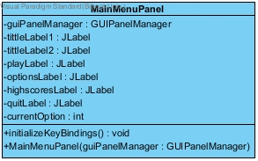

* During implementation, we decided to use JLabel’s for buttons due to the fact that we are using KeyBindings as a keyboard listener.

**Attributes**

|  |  |  |  |
| --- | --- | --- | --- |
| private | guiPanelManager | GUIPanelManager | MainMenuPanel calls setVisible() methods in GUIPanelManager via this object |
| private | tittleLabel1 | JLabel | 1st part of the tittle, it says "Donkey" |
| private | tittleLabel2 | JLabel | 2nd part of the tittle, it says "Kong" |
| private | playLabel | JLabel | Label for play button |
| private | optionsLabel | JLabel | Label for options button |
| private | highscoresLabel | JLabel | Label for highscores button |
| private | quitLabel | JLabel | Label for quit button |
| private | currentOption | int | Work as an indicator for button labels |

**Constructors**

|  |  |  |
| --- | --- | --- |
| public | MainMenuPanel(guiPanelManager : GUIPanelManager) | Creates a MainMenuPanel object that organize how main menu should look |

**Methods**

|  |  |  |  |
| --- | --- | --- | --- |
| public | initializeKeyBindings() | void | Create the interaction between JPanel and Keyboard inputs and focuses the current panel |

* + - 1. **HighscoresPanel Class**

HighscoresPanel class creates a highscore panel and its components in order to display in GUIPanelManager. All of the attributes in this class is for user interface design.

* HighscoresPanel extends JPanel
* It has a nested class called KeyHandler which allow HighScoresPanel class to take inputs from user.

Figure 3.2.1.4: HighscoresPanel Class

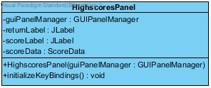

* During implementation, we decided to use JLabel’s for buttons due to the fact that we are using KeyBindings as a keyboard listener.

**Attributes**

|  |  |  |  |
| --- | --- | --- | --- |
| private | guiPanelManager | GUIPanelManager | HighscoresPanel calls setVisible() methods in GUIPanelManager via this object |
| private | returnLabel | JLabel | Label for return button |
| private | scoreLabel | JLabel | Scores taken from ScoreData object will be displayed inside this label |
| private | scoreData | ScoreData | Provide a highscore table for HighscoresPanel class |

**Constructors**

|  |  |  |
| --- | --- | --- |
| public | HighscoresPanel(guiPanelManager : GUIPanelManager) | Creates a HighscoresPanel object that organize how highscores should look |

**Methods**

|  |  |  |  |
| --- | --- | --- | --- |
| public | initializeKeyBindings() | void | Create the interaction between JPanel and Keyboard inputs and focuses the current panel |

* + - 1. **LevelSelectionPanel Class**

LevelSelectionPanel class creates a level selection panel and its components in order to display in GUIPanelManager. It also interact with UnlockData class in GameManager to show which levels are open to user. All of the attributes in this class is for user interface design.

* LevelSelectionPanel extends JPanel
* It has a nested class called KeyHandler which allow LevelSelectionPanel class to take inputs from user.

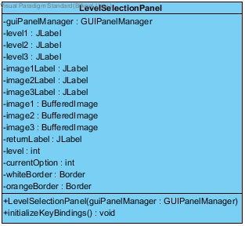

Figure 3.2.1.5: LevelSelectionPanel Class

* During implementation, we decided to use JLabel’s for buttons due to the fact that we are using KeyBindings as a keyboard listener.

**Attributes**

|  |  |  |  |
| --- | --- | --- | --- |
| private | guiPanelManager | GUIPanelManager | LevelSelectionPanel calls setVisible() methods in GUIPanelManager via this object |
| private | level1 | JLabel | Label for level 1 button |
| private | level2 | JLabel | Label for level 2 button |
| private | level3 | JLabel | Label for level 3 button |
| private | imageLevel1 | JLabel | Level 1 image will be displayed inside this label |
| private | imageLevel2 | JLabel | Level 1 image will be displayed inside this label |
| private | imageLevel3 | JLabel | Level 1 image will be displayed inside this label |
| private | image1 | BufferedImage | Keeps the image of level1 in order to display inside imageLevel1 |
| private | image2 | BufferedImage | Keeps the image of level2 in order to display inside imageLevel2 |
| private | image3 | BufferedImage | Keeps the image of level3 in order to display inside imageLevel3 |
| private | returnLabel | JLabel | Label for return button |
| private | level | int | Keeps the selected level number in order to call setGamePanelVisible(level : int) with it when user presses appropriated keyboard input which initialize inside initializeKeyBindings() method |
| private | currentOption | int | Work as an indicator for button labels |
| private | whiteBorder | Border | Visualized version of currentOption attribute. If an image has a white border, this means it is not selected. |
| private | orangeBorder | Border | Visualized version of currentOption attribute. If an image has an orange border, this means it is selected currently. |

**Constructors**

|  |  |  |
| --- | --- | --- |
| public | LevelSelectionPanel(guiPanelManager : GUIPanelManager) | Creates a LevelSelectionPanel object that organize how level selection should look |

**Methods**

|  |  |  |  |
| --- | --- | --- | --- |
| public | initializeKeyBindings() | void | Create the interaction between JPanel and Keyboard inputs and focuses the current panel |

* + - 1. **OptionsPanel Class**

OptionsPanel class creates an option panel and its components in order to display in GUIPanelManager. All of the attributes in this class is for user interface design.

* OptionsPanel extends JPanel
* It has a nested class called KeyHandler which allow OptionsPanel class to take inputs from user.

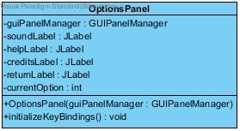

Figure 3.2.1.6: OptionsPanel Class

* During implementation, we decided to use JLabel’s for buttons due to the fact that we are using KeyBindings as a keyboard listener.

**Attributes**

|  |  |  |  |
| --- | --- | --- | --- |
| private | guiPanelManager | GUIPanelManager | OptionsPanel calls setVisible() methods in GUIPanelManager via this object |
| private | soundLabel | JLabel | Label for turn on/off sound button |
| private | helpLabel | JLabel | Label for help button |
| private | creditsLabel | JLabel | Label for credits button |
| private | returnLabel | JLabel | Level for return button |
| private | currentOption | int | Work as an indicator for button labels |

**Constructors**

|  |  |  |
| --- | --- | --- |
| public | OptionsPanel(guiPanelManager : GUIPanelManager) | Creates a OptionsPanel object that organize how options panel should look |

**Methods**

|  |  |  |  |
| --- | --- | --- | --- |
| public | initializeKeyBindings() | void | Create the interaction between JPanel and Keyboard inputs and focuses the current panel |

* + - 1. **HelpPanel Class**

HelpPanel class creates an option panel and its components in order to display in GUIPanelManager. All of the attributes in this class is for user interface design.

* HelpPanel extends JPanel
* It has a nested class called KeyHandler which allow HelpPanel class to take inputs from user.

Figure 3.2.1.7: HelpPanel Class

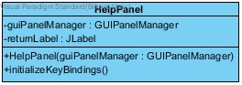

* During implementation, we decided to use JLabel’s for buttons due to the fact that we are using KeyBindings as a keyboard listener.

**Attributes**

|  |  |  |  |
| --- | --- | --- | --- |
| private | guiPanelManager | GUIPanelManager | HelpPanel calls setVisible() methods in GUIPanelManager via this object |
| private | returnLabel | JLabel | Level for return button |

**Constructors**

|  |  |  |
| --- | --- | --- |
| public | OptionsPanel(guiPanelManager : GUIPanelManager) | Creates a OptionsPanel object that organize how options panel should look |

**Methods**

|  |  |  |  |
| --- | --- | --- | --- |
| public | initializeKeyBindings() | void | Create the interaction between JPanel and Keyboard inputs and focuses the current panel |

* + - 1. **CreditsClass Class**

CreditsPanel class creates an option panel and its components in order to display in GUIPanelManager. All of the attributes in this class is for user interface design.

* CreditsPanel extends JPanel
* It has a nested class called KeyHandler which allow CreditsPanel class to take inputs from user.

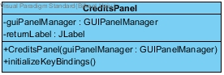

Figure 3.2.1.8: CreditsPanel Class

* During implementation, we decided to use JLabel’s for buttons due to the fact that we are using KeyBindings as a keyboard listener.

**Attributes**

|  |  |  |  |
| --- | --- | --- | --- |
| private | guiPanelManager | GUIPanelManager | CreditsPanel calls setVisible() methods in GUIPanelManager via this object |
| private | returnLabel | JLabel | Level for return button |

**Constructors**

|  |  |  |
| --- | --- | --- |
| public | CreditsPanel (guiPanelManager : GUIPanelManager) | Creates a CreditsPanel object that organize how options panel should look |

**Methods**

|  |  |  |  |
| --- | --- | --- | --- |
| public | initializeKeyBindings() | void | Create the interaction between JPanel and Keyboard inputs and focuses the current panel |

* + - 1. **GamePanel Class**

GamePanel class display the game state with respect to data sent by Controller class inside GameManager Subsystem. This class does not interact with user unlike other classes inside User Interface Subsystem because GamePanel has no knowledge about game state. User inputs will interpret inside GameEngine class and GamePanel class takes the state of the game via Controller class to display it on the screen.

* CreditsPanel extends JPanel

Figure 3.2.1.9: GamePanel Class

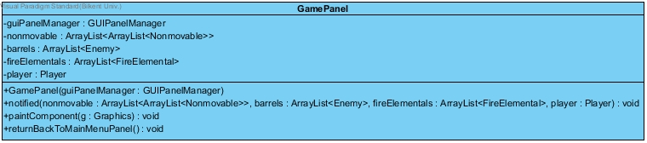

**Attributes**

|  |  |  |  |
| --- | --- | --- | --- |
| private | guiPanelManager | GUIPanelManager | GamePanel calls setVisible() methods in GUIPanelManager via this object |
| private | nonmovable | ArrayList<ArrayList<Nonmovable>> | Keeps Nonmovable object such as Girl, Monkey and Ladder, etc. in order to use in paintComponent(g: Graphics) method. |
| private | barrels | ArrayList<Enemy> | Keeps Barrel objects in order to use in paintComponent(g: Graphics) method. |
| private | fireElementals | ArrayList<FireElemental> | Keeps FireElemental objects in order to use in paintComponent(g: Graphics) method. |
| private | player | Player | Keeps Player objects in order to use in paintComponent(g: Graphics) method. |

* Nonmovable, barrels, fireElementals and player has a instance inside this class in order to reach them paintComponent(g : Graphics) method easily. Otherwise there is no reason to keep them as objects.

**Constructors**

|  |  |  |
| --- | --- | --- |
| public | GamePanel (guiPanelManager : GUIPanelManager) | Creates a GamePanel object that renders game state on screen |

**Methods**

|  |  |  |  |
| --- | --- | --- | --- |
| public | initializeKeyBindings() | void | Create the interaction between JPanel and Keyboard inputs and focuses the current panel |
| public | notified(nonmovable : ArrayList<ArrayList<Nonmovable>>, barrels : ArrayList<Enemy>, fireElementals : ArrayList<FireElementals>, player : Player) | void | Controller class uses this method in order to notify GamePanel. This method set old attributes with new ones and calls repaint() method to re-render the screen |
| public | returnBackToMainMenuPanel() | void | Create the interaction between JPanel and Keyboard inputs and focuses the current panel |
| public | paintComponent(g : Graphics)* | void | Organizes map objects according to their X and Y coordinates and display them. |

* (*) paintComponent(g : Graphics) is not called directly. GamePanel uses repaint() method to call paintComponent(g: Graphics) method to render the screen.

### Game Manager Subsystem

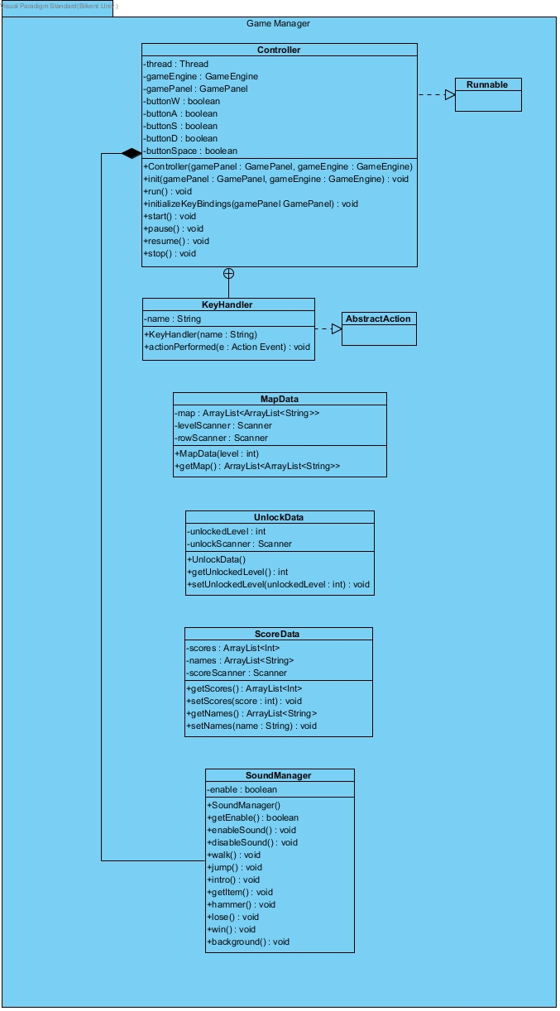

Figure 3.2.2: Game Manager Subsystem

* + - 1. **SoundManager** **Class**

SoundManager class make sounds via methods such as walk() or jump(). Controller class commonly uses SoundManager to play sounds during game play. There is no logic inside this class, it play the sound according to which method is called. In other words, Controller class manages which sound will be played via SoundManager’s methods. Also OptionPanel uses the same SoundManager object to enable or disable the sound.

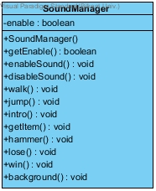

Figure 3.2.2.1: SoundManager Class

**Attributes**

|  |  |  |  |
| --- | --- | --- | --- |
| private | enable | boolean | Determines whether SoundManager make sound. If enable is true, SoundManager can work normally. However if enable is false, even though you call a method, SoundManager will not make sounds. |

**Constructors**

|  |  |  |
| --- | --- | --- |
| public | SoundManager() | Creates a SoundManager object that make sounds according to which of its method is called |

**Methods**

|  |  |  |  |
| --- | --- | --- | --- |
| public | getEnable() | boolean | Returns the value of enable. |
| public | enableSound() | void | Basically a setter for enable, OptionPanel uses this method to turn on the sound. |
| public | disableSound() | void | Basically a setter for enable, OptionPanel uses this method to turn off the sound. |
| public | walk() | void | Make walking sound for Controller class to use it during game |
| public | jump() | void | Make jumping sound for Controller class to use it during game |
| public | intro() | void | Make intro sound for Controller class to use it during game |
| public | getItem() | void | Make getting item sound such as getting a coin or extra life for Controller class to use it during game |
| public | hammer() | void | Make hammer strike sound for Controller class to use it during game |
| public | lose() | void | Make lose sound for Controller class to use it during game |
| public | win() | void | Make win sound for Controller class to use it during game |
| public | background() | void | Make background sound for Controller class to use it during game |

* + - 1. **ScoreData** **Class**

ScoreData class stores the highscore datas inside a text file in order to preserve it for following execution of the game. The highscore datas should be stored for next execution of the game. Otherwise every execution, highscores will be lost. Therefore ScoreData class keeps highscores inside a text file.

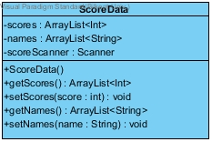

Figure 3.2.2.2: ScoreData Class

**Attributes**

|  |  |  |  |
| --- | --- | --- | --- |
| private | scores | ArrayList<int> | An ArrayList to store scores of players with respect to their index. HighScorePanel class uses this ArrayList to reach highscores. |
| private | names | ArrayList<String> | An ArrayList to store names of players with respect to their index. HighScorePanel class uses this ArrayList to reach the names of players. |
| private | scoreScanner | Scanner | Scanner for score text file |

**Constructors**

|  |  |  |
| --- | --- | --- |
| public | ScoreData() | Creates a ScoreData object that stores the highscores. |

**Methods**

|  |  |  |  |
| --- | --- | --- | --- |
| public | getScores() | ArrayList<int> | Returns the value of scores for other classes |
| public | setScores(score: int) | void | When a highscore detected, setScores(score: int) is used to store the new highscore. |
| public | getNames() | ArrayList<String> | Returns the value of names for other classes |
| public | setNames(name : String) | void | When a highscore detected, setNames(score: int) is used to store the name of the player. |

* + - 1. **UnlockData** **Class**

UnlockData class stores the unlocked levels inside a text file in order to preserve it for following execution of the game. Purpose of this class is same as ScoreData, which is preserve the progress of user. Every execution of the mage, user should not be force to play all the levels to unlock them.

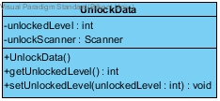

Figure 3.2.2.3: UnlockData Class

**Attributes**

|  |  |  |  |
| --- | --- | --- | --- |
| private | unlockedLevel | int | An int to store unlocked level. LevelSelectionPanel class uses this int to display user which levels he/she can play. |
| private | unlockScanner | Scanner | Scanner for unlockLevel text file |

**Constructors**

|  |  |  |
| --- | --- | --- |
| public | UnlockData() | Creates a UnlockData object that stores the index of last level unlocked |

**Methods**

|  |  |  |  |
| --- | --- | --- | --- |
| public | getUnlockedLevel() | int | Returns the the index of last level unlocked |
| public | setUnlockedLevel(unlockedLevel : int) | void | When user successfully finish a level, this method is called to save his/her progress. |

* + - 1. **MapData** **Class**

MapData class provides game maps for GameEngine class. Similarly levels also stored inside text files. Unlike ScoreData or MapData, no one can change the starting state of the map.

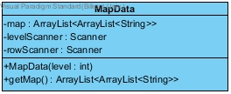

Figure 3.2.2.4: MapData Class

**Attributes**

|  |  |  |  |
| --- | --- | --- | --- |
| private | map | ArrayList<ArrayList<String>> | An 2D ArrayList to store starting state of the game for GameEngine class. |
| private | levelScanner | Scanner | Scanner for level text file |
| private | rowScanner | Scanner | Scanner for level text file |

* The reason we are using 2 Scanner is that levels are stored as matrixes inside text file. One is move around rows and other one is cols.

**Constructors**

|  |  |  |
| --- | --- | --- |
| public | MapData(level : int) | Creates a MapData objects according to the level input. For example MapData(1) provides level 1 map and MapData(2) provides level 2 map |

**Methods**

|  |  |  |  |
| --- | --- | --- | --- |
| public | getMap() | ArrayList<ArrayList<String>> | Returns the 2D ArrayList which stores starting state of the game. GameEngine class calls this method. |

* + - 1. **Controller** **Class**

Controller class creates the connection between GameEngine class and GamePanel class.

* Controller implements Runnable
* Controller class uses a thread to check whether or not user enters a keyboard input.
* Controller class decides which sound will be played according to inputs from GameEngine class.

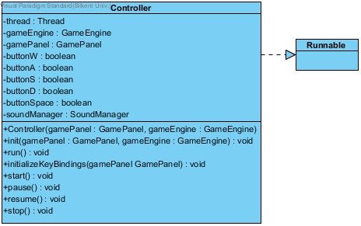

**Attributes**

Figure 3.2.2.5: Controller Class

|  |  |  |  |
| --- | --- | --- | --- |
| private | thread | Thread | A thread to run the game. |
| private | gameEngine | GameEngine | GameEngine object which provide game states and game algorithms |
| private | gamePanel | GamePanel | GamePanel object which render the game state taken from GameEngine object. To render the screen Controller calls notify method inside GamePanel |
| private | buttonW | boolean | Indicate if W button pressed. |
| private | buttonA | boolean | Indicate if A button pressed. |
| private | buttonS | boolean | Indicate if S button pressed. |
| private | buttonD | boolean | Indicate if D button pressed. |
| private | buttonSpace | boolean | Indicate if SPACE button pressed. |
| private | soundManager | SoundManager | Controller makes sound by using this SoundManager object. |

* We have 5 different Booleans for KeyBindings. The reasoning behind this is that to detect 2 KeyBinding at the same time. If we uses actionPermormed(e : ActionEvent) to call events in GameEngine, it only calls the 1st button pressed.

**Constructors**

|  |  |  |
| --- | --- | --- |
| public | Controller(gamePanel : GamePanel, gameEngine : GameEngine) | Creates a Controller establish the connection between GamePanel and GameEngine. |

**Methods**

|  |  |  |  |
| --- | --- | --- | --- |
| public | init() | void | Initialization method for Controller |
| public | run() | void | Override method from Runnable. When we start the thread, it automatically calls run() method. |
| public | initializeKeyBindings(gamePanel : GamePanel) | void | Create the interaction between GamePanel and Keyboard inputs and focuses GamePanel. |
| public | start() | void | Initialize a new thread and starts it |
| public | pause() | void | Pause the game by calling setMovement(False) |
| public | resume() | void | Resume the game by calling setMovement(True) |
| public | stop() | void | Stops the thread |

* run() is a special method because it has a while loop inside that loops until game is over. It constantly ask for a new game state form GameEngine and notify GamePanel to display that game state.

### Game Subsystem

The Game Subsystem class diagram is attached to the next page in order to provide a better look on interactions between classes.

Figure 3.2.3: Game Subsystem

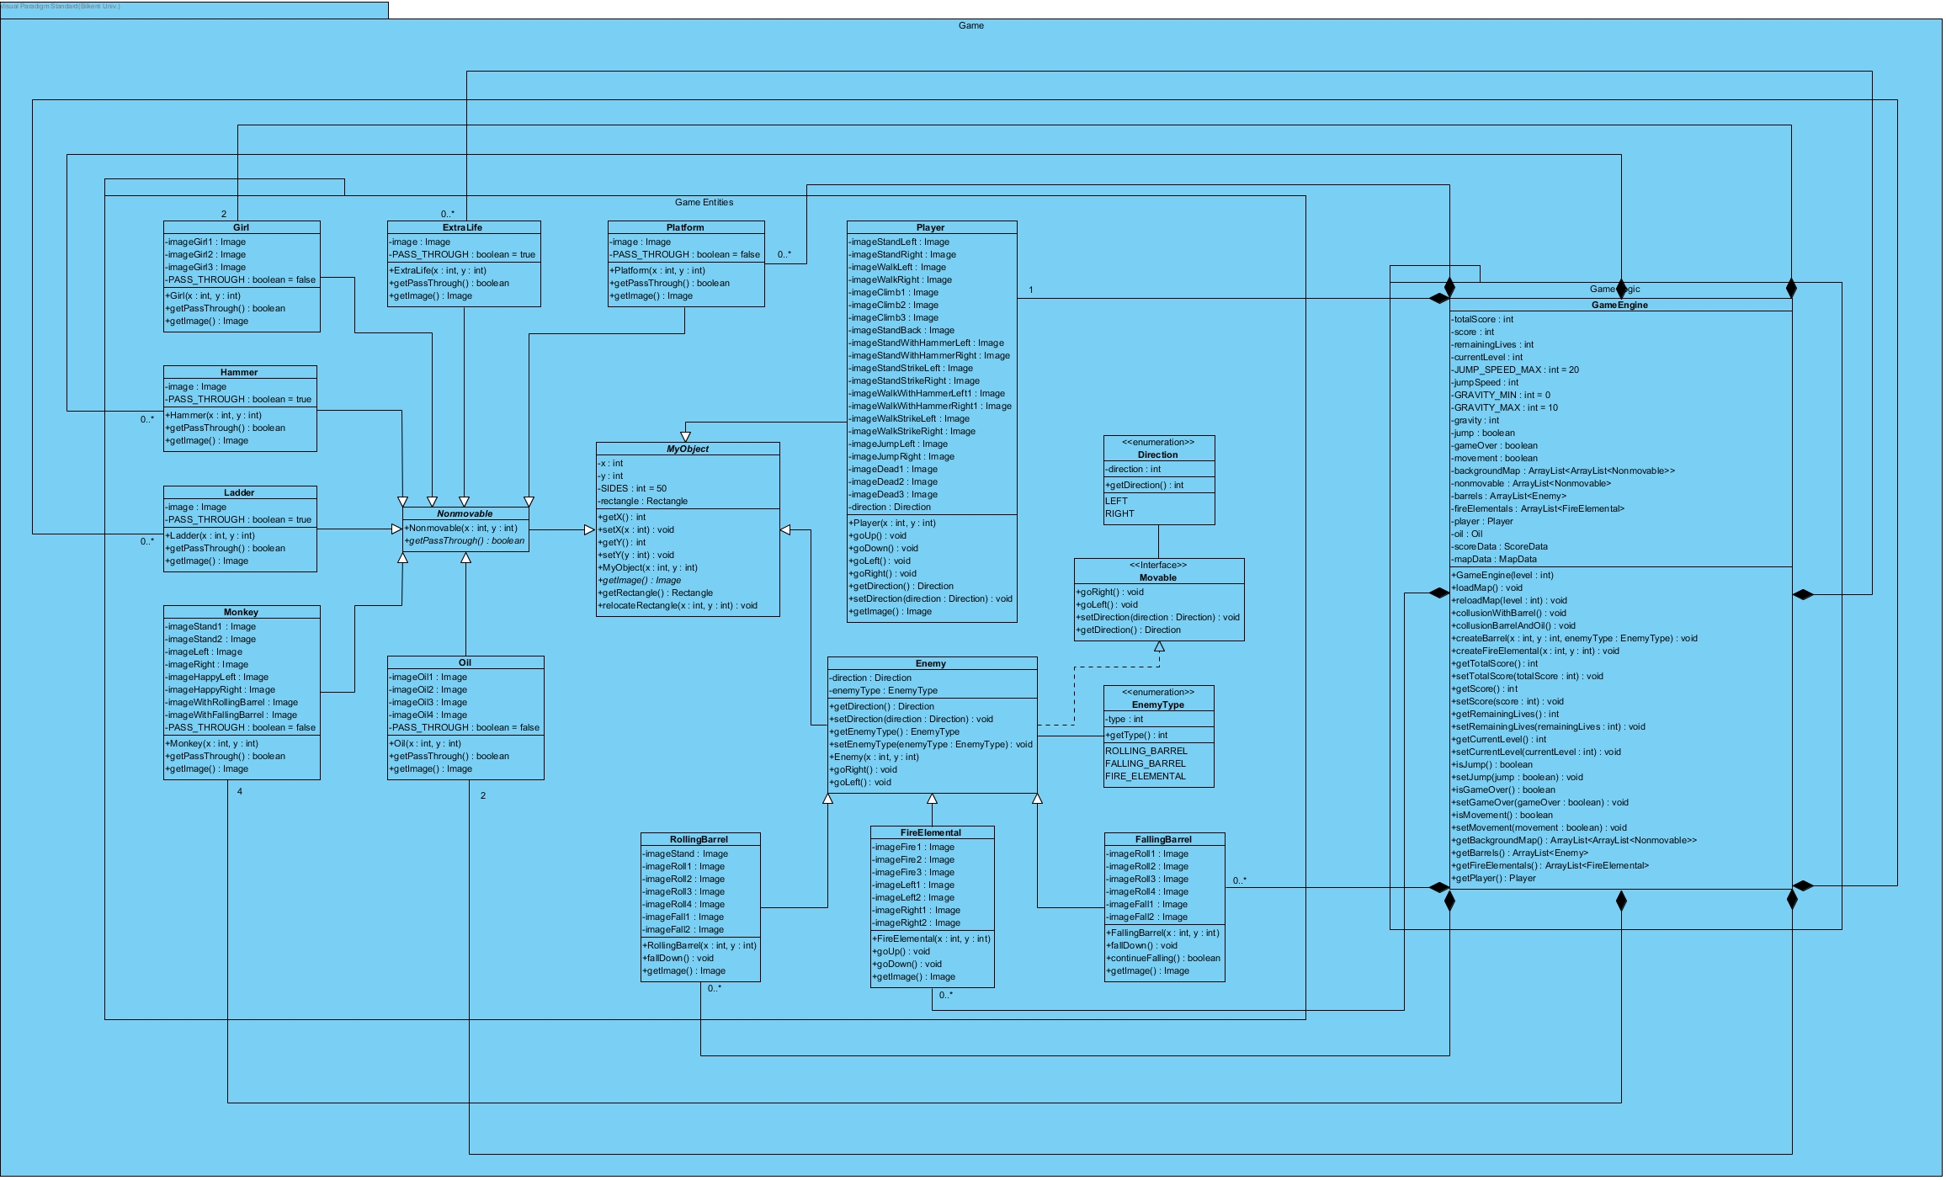

* + - 1. **MyObject Abstract** **Class**

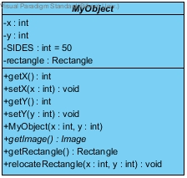

Figure 3.2.3: MyObject Abtract Class

**Attributes**

|  |  |  |  |
| --- | --- | --- | --- |
| private | x | int | X-coordinate of the object |
| private | y | int | Y-coordi |
| private | gamePanel | GamePanel | GamePanel object which render the game state taken from GameEngine object. To render the screen Controller calls notify method inside GamePanel |
| private | buttonW | boolean | Indicate if W button pressed. |

* We have 5 different Booleans for KeyBindings. The reasoning behind this is that to detect 2 KeyBinding at the same time. If we uses actionPermormed(e : ActionEvent) to call events in GameEngine, it only calls the 1st button pressed.

**Constructors**

|  |  |  |
| --- | --- | --- |
| public | Controller(gamePanel : GamePanel, gameEngine : GameEngine) | Creates a Controller establish the connection between GamePanel and GameEngine. |

**Methods**

|  |  |  |  |
| --- | --- | --- | --- |
| public | init() | void | Initialization method for Controller |
| public | run() | void | Override method from Runnable. When we start the thread, it automatically calls run() method. |
| public | initializeKeyBindings(gamePanel : GamePanel) | void | Create the interaction between GamePanel and Keyboard inputs and focuses GamePanel. |
| public | start() | void | Initialize a new thread and starts it |
| public | pause() | void | Pause the game by calling setMovement(False) |
| public | resume() | void | Resume the game by calling setMovement(True) |
| public | stop() | void | Stops the thread |